1. FIND-S ALGORITHM
data = [
['Sunny','Warm','Normal','Strong','Warm','Same','Yes'],
['Sunny','Warm','High','Strong','Warm','Same','Yes'],
['Rainy','Cold','High','Strong','Warm','Change','No']
]
h = ['0'] * 6
for r in data:
if r[-1] == 'Yes':
for i in range(6):
if h[i] == '0':
h[i] = r[i]
elif h[i] != r[i]:
h[i] = '?'
print(h)
Output
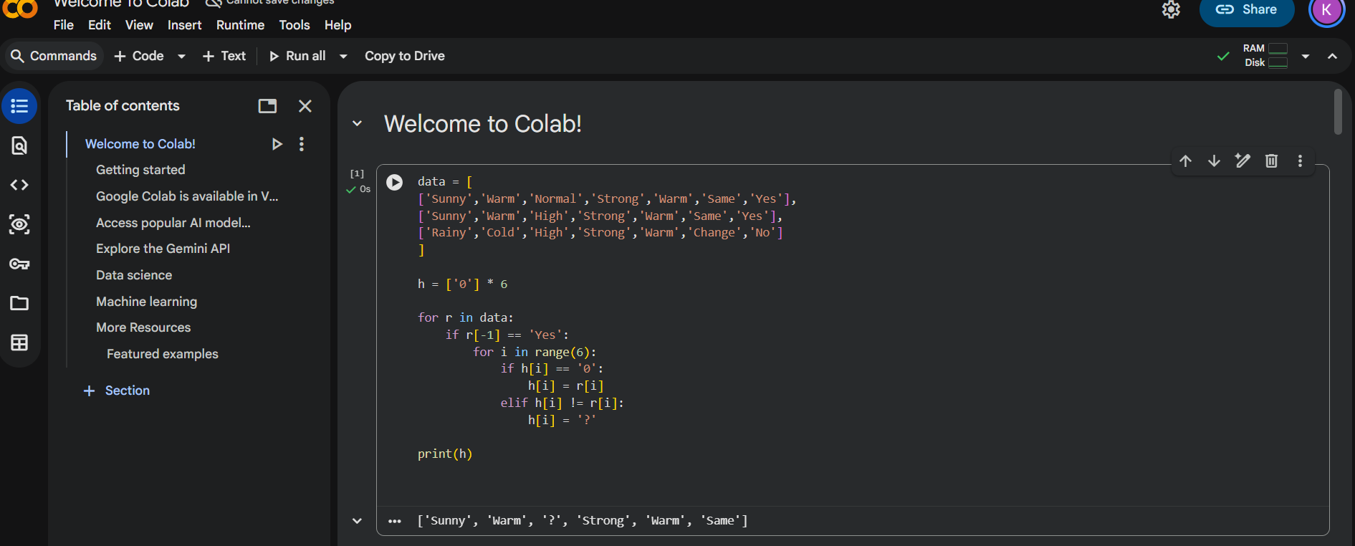

# 2. CANDIDATE ELIMINATION
data = [
['Sunny','Warm','Normal','Strong','Warm','Same','Yes'],
['Sunny','Warm','High','Strong','Warm','Same','Yes'],
['Rainy','Cold','High','Strong','Warm','Change','No']
]
S = ['0'] * 6
G = ['?'] * 6
for r in data:
if r[-1] == 'Yes':
for i in range(6):
if S[i] == '0':
S[i] = r[i]
elif S[i] != r[i]:
S[i] = '?'
print("S =", S)
print("G =", G)
Output
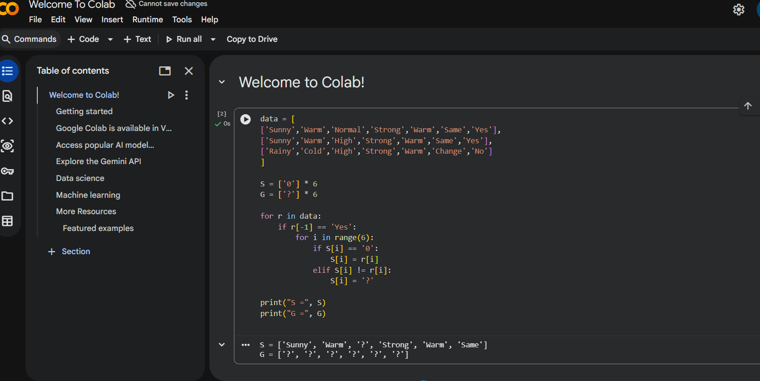

# 3. ID3 DECISION TREE
from sklearn.datasets import load_iris
from sklearn.tree import DecisionTreeClassifier
d = load_iris()
m = DecisionTreeClassifier(
criterion='entropy',
random_state=1
)
m.fit(d.data, d.target)
print(m.predict([[5.1,3.5,1.4,0.2]]))
Output
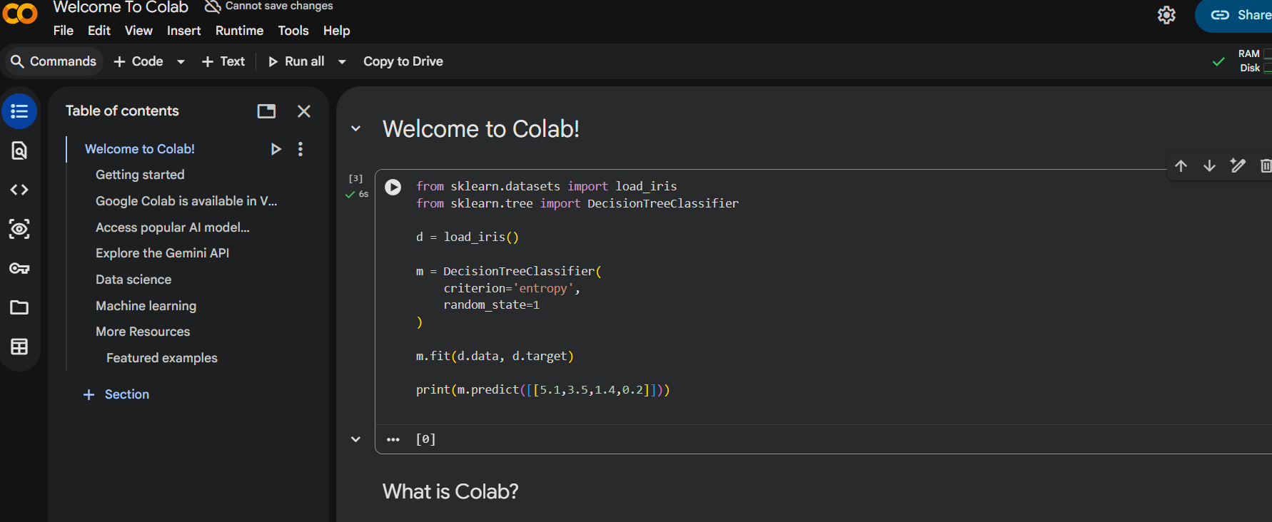
# 4. ANN BACKPROPAGATION
from sklearn.neural_network import MLPClassifier
X = [[0,0],[0,1],[1,0],[1,1]]
y = [0,1,1,0]
m = MLPClassifier(
hidden_layer_sizes=(4,),
max_iter=5000,
random_state=1
)
m.fit(X, y)
print(m.predict([[1,0]]))

Output
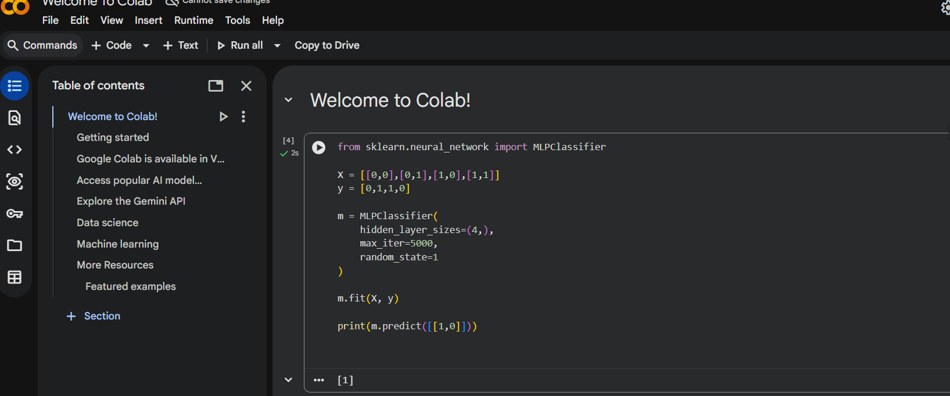
# 5. KNN
from sklearn.datasets import load_iris
from sklearn.neighbors import KNeighborsClassifier
d = load_iris()
m = KNeighborsClassifier(3)
m.fit(d.data, d.target)
print(m.predict([[5.1,3.5,1.4,0.2]]))
Output
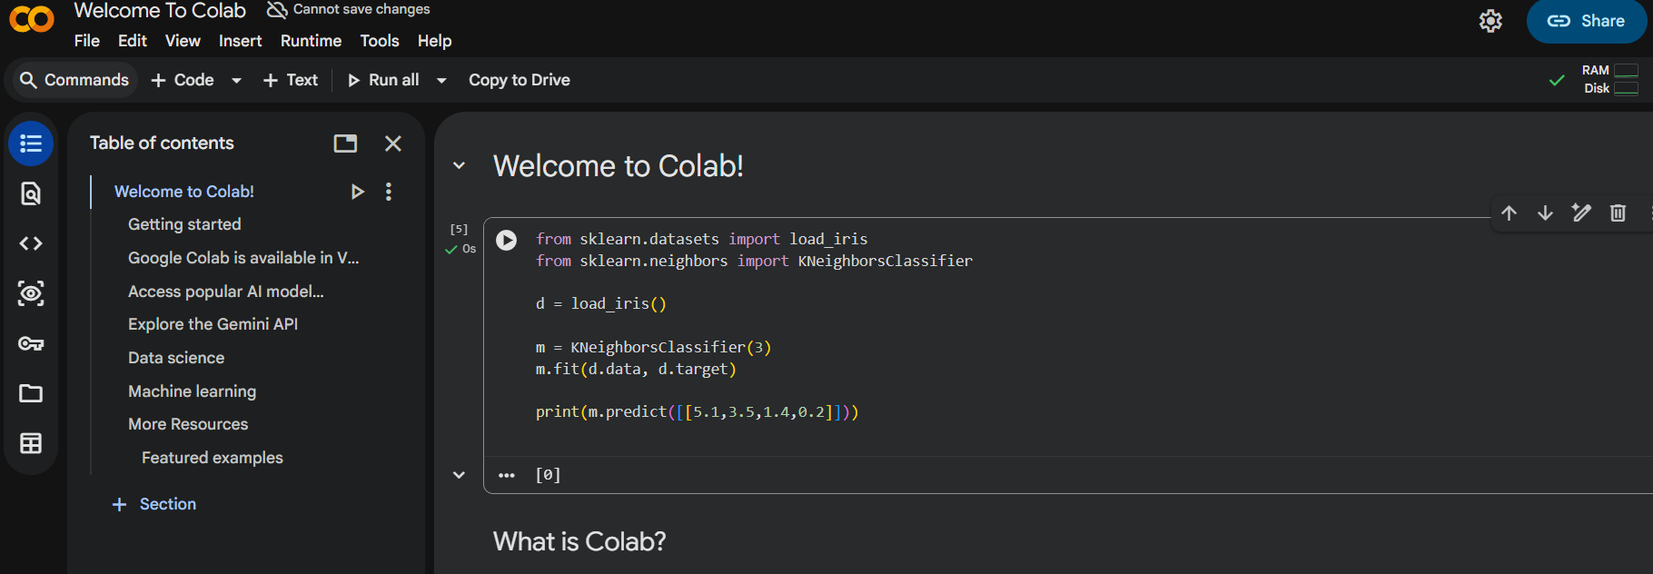

# 6. NAIVE BAYES
from sklearn.datasets import load_iris
from sklearn.naive_bayes import GaussianNB
from sklearn.metrics import accuracy_score, confusion_matrix
d = load_iris()
m = GaussianNB()
m.fit(d.data, d.target)
p = m.predict(d.data)
print("Accuracy:", accuracy_score(d.target,p))
print("Confusion Matrix:")
print(confusion_matrix(d.target,p))
Output
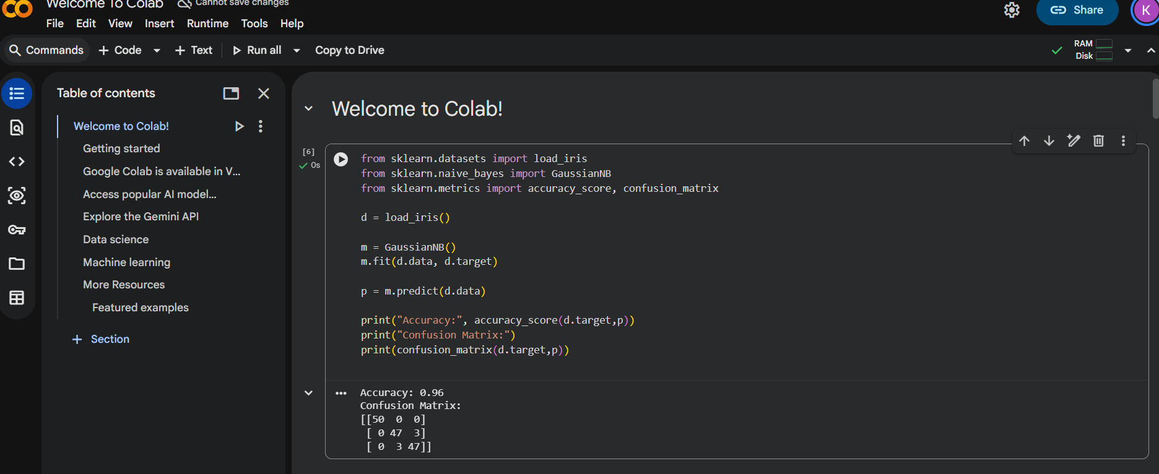

# 7. LOGISTIC REGRESSION
from sklearn.datasets import load_iris
from sklearn.linear_model import LogisticRegression
d = load_iris()
m = LogisticRegression(max_iter=200)
m.fit(d.data, d.target)
print(m.predict([[5.1,3.5,1.4,0.2]]))

Output
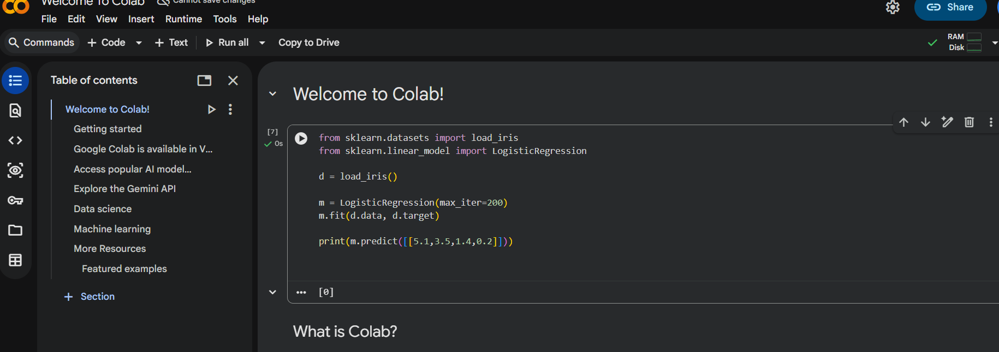

# 8. LINEAR REGRESSION
from sklearn.linear_model import LinearRegression
X = [[1],[2],[3],[4],[5]]
y = [2,4,6,8,10]
m = LinearRegression()
m.fit(X,y)
print(m.predict([[6]]))
Output
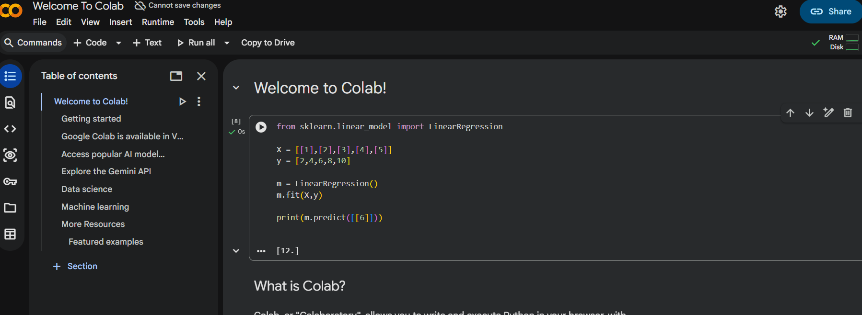

# 9. LINEAR VS POLYNOMIAL
from sklearn.linear_model import LinearRegression
from sklearn.preprocessing import PolynomialFeatures

X = [[1],[2],[3],[4]]
y = [1,4,9,16]
l = LinearRegression()
l.fit(X,y)
p = PolynomialFeatures(2)
X_poly = p.fit_transform(X)
q = LinearRegression()
q.fit(X_poly,y)
print("Linear:", round(l.predict([[5]])[0],2))
print("Polynomial:", round(q.predict(p.transform([[5]]))[0],2))
Output
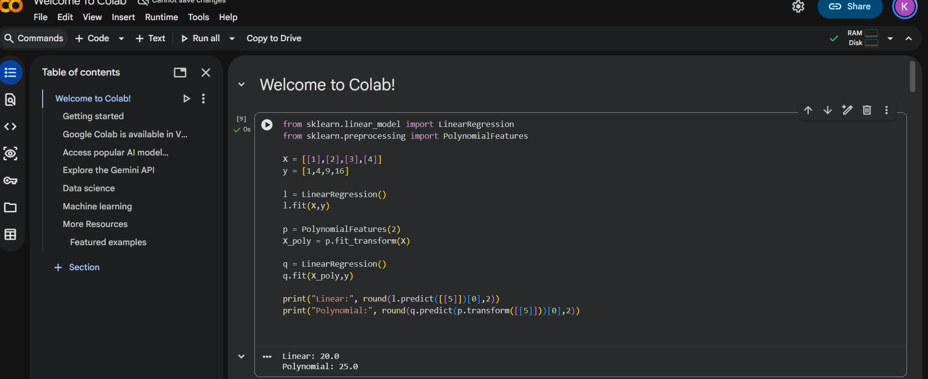

# 10. EXPECTATION MAXIMIZATION
from sklearn.mixture import GaussianMixture
X = [[1,1],[1,2],[4,5],[5,6]]
m = GaussianMixture(
n_components=2,
random_state=1
)
m.fit(X)
print(m.predict(X))

Output
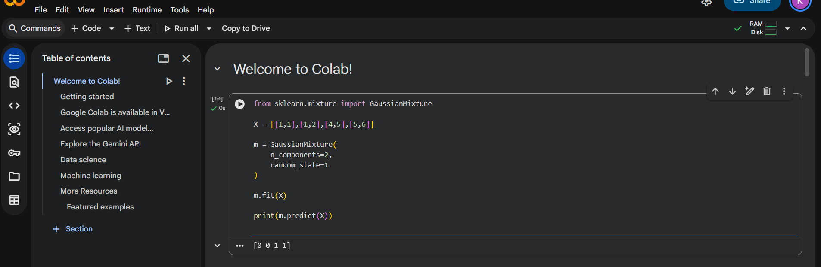

# 11. CREDIT SCORE CLASSIFICATION
from sklearn.tree import DecisionTreeClassifier
X = [
[20,20000],
[25,30000],
[35,60000],
[45,90000]
]
y = ['Poor','Poor','Average','Good']
m = DecisionTreeClassifier(random_state=1)
m.fit(X,y)
print(m.predict([[35,60000]]))
Output
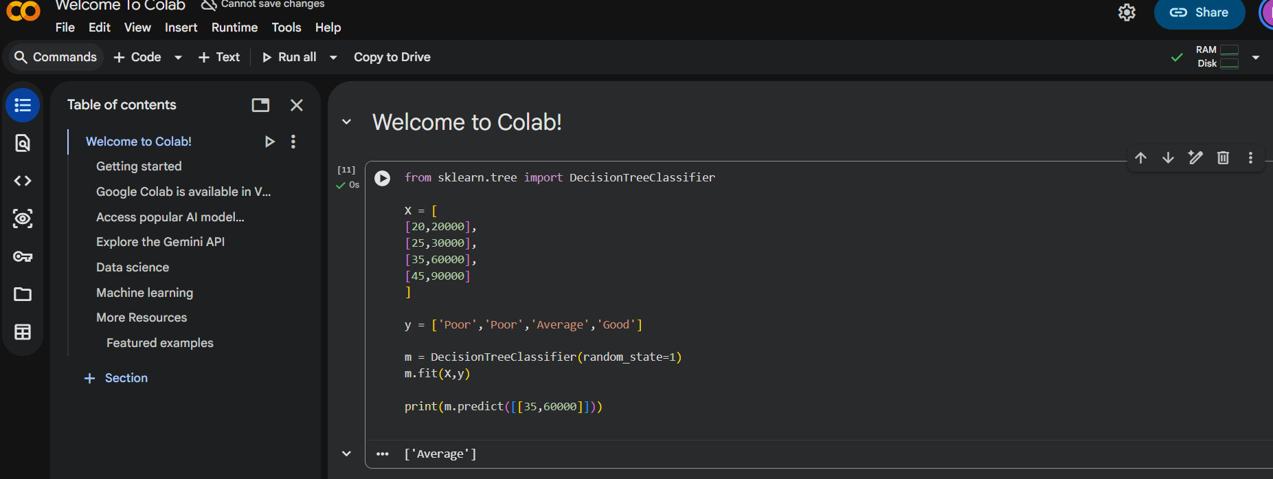

# 12. IRIS FLOWER USING KNN
from sklearn.datasets import load_iris
from sklearn.neighbors import KNeighborsClassifier
d = load_iris()
m = KNeighborsClassifier(3)
m.fit(d.data,d.target)
p = m.predict([[5.1,3.5,1.4,0.2]])
print(d.target_names[p][0])
Output
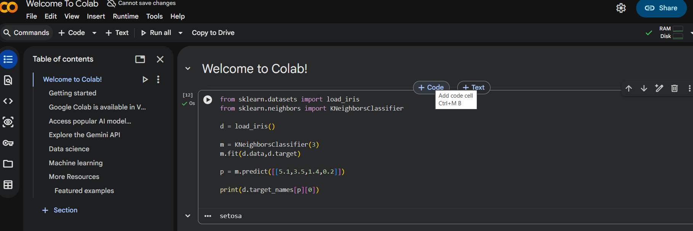

# 13. CAR PRICE PREDICTION
from sklearn.linear_model import LinearRegression
X = [
[10000],
[20000],
[30000],
[40000]
]
y = [900000,800000,700000,600000]
m = LinearRegression()
m.fit(X,y)
print(round(m.predict([[15000]])[0]))

Output
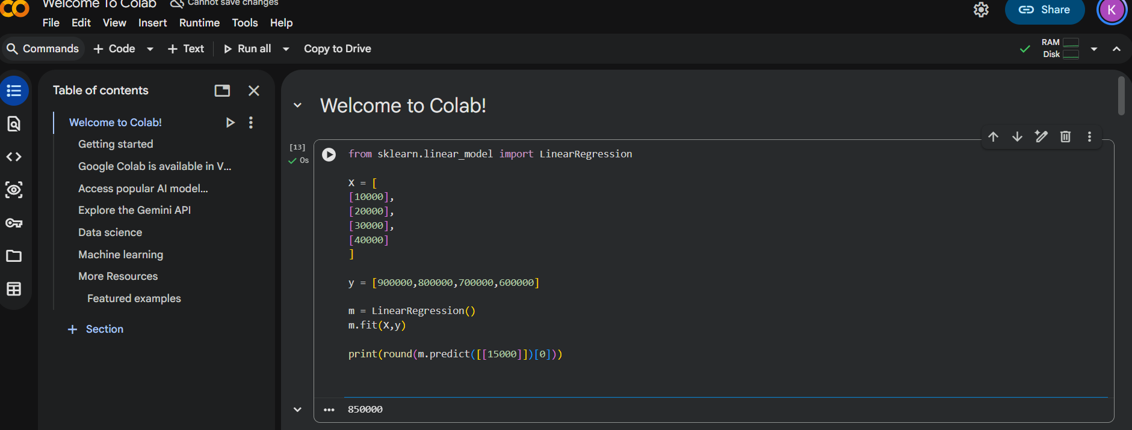

# 14. HOUSE PRICE PREDICTION
from sklearn.linear_model import LinearRegression
X = [
[1000],
[1500],
[2000]
]
y = [3000000,4500000,6000000]
m = LinearRegression()
m.fit(X,y)
print(round(m.predict([[1600]])[0]))
Output
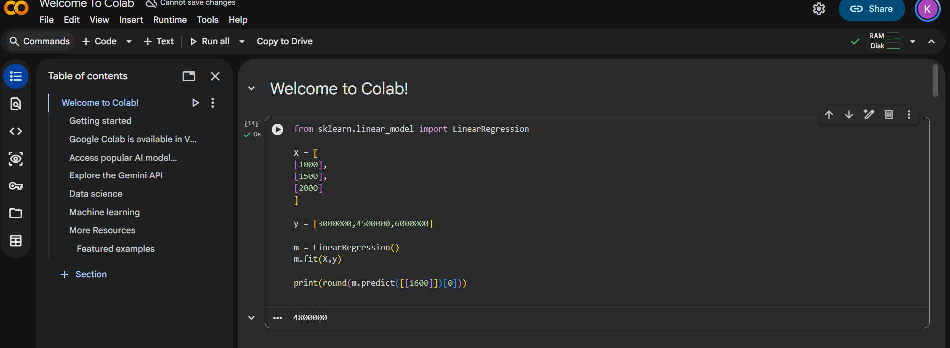

# 15. IRIS USING NAIVE BAYES
from sklearn.datasets import load_iris
from sklearn.naive_bayes import GaussianNB
d = load_iris()
m = GaussianNB()
m.fit(d.data,d.target)
p = m.predict([[5.1,3.5,1.4,0.2]])
print(d.target_names[p][0])
Output


# 16. COMPARE CLASSIFICATION ALGORITHMS
from sklearn.datasets import load_iris
from sklearn.neighbors import KNeighborsClassifier
from sklearn.tree import DecisionTreeClassifier
from sklearn.naive_bayes import GaussianNB
d = load_iris()
models = [
KNeighborsClassifier(),
DecisionTreeClassifier(random_state=1),
GaussianNB()
]
for m in models:
m.fit(d.data,d.target)
print(
type(m).__name__,
round(m.score(d.data,d.target),2)
)
Output
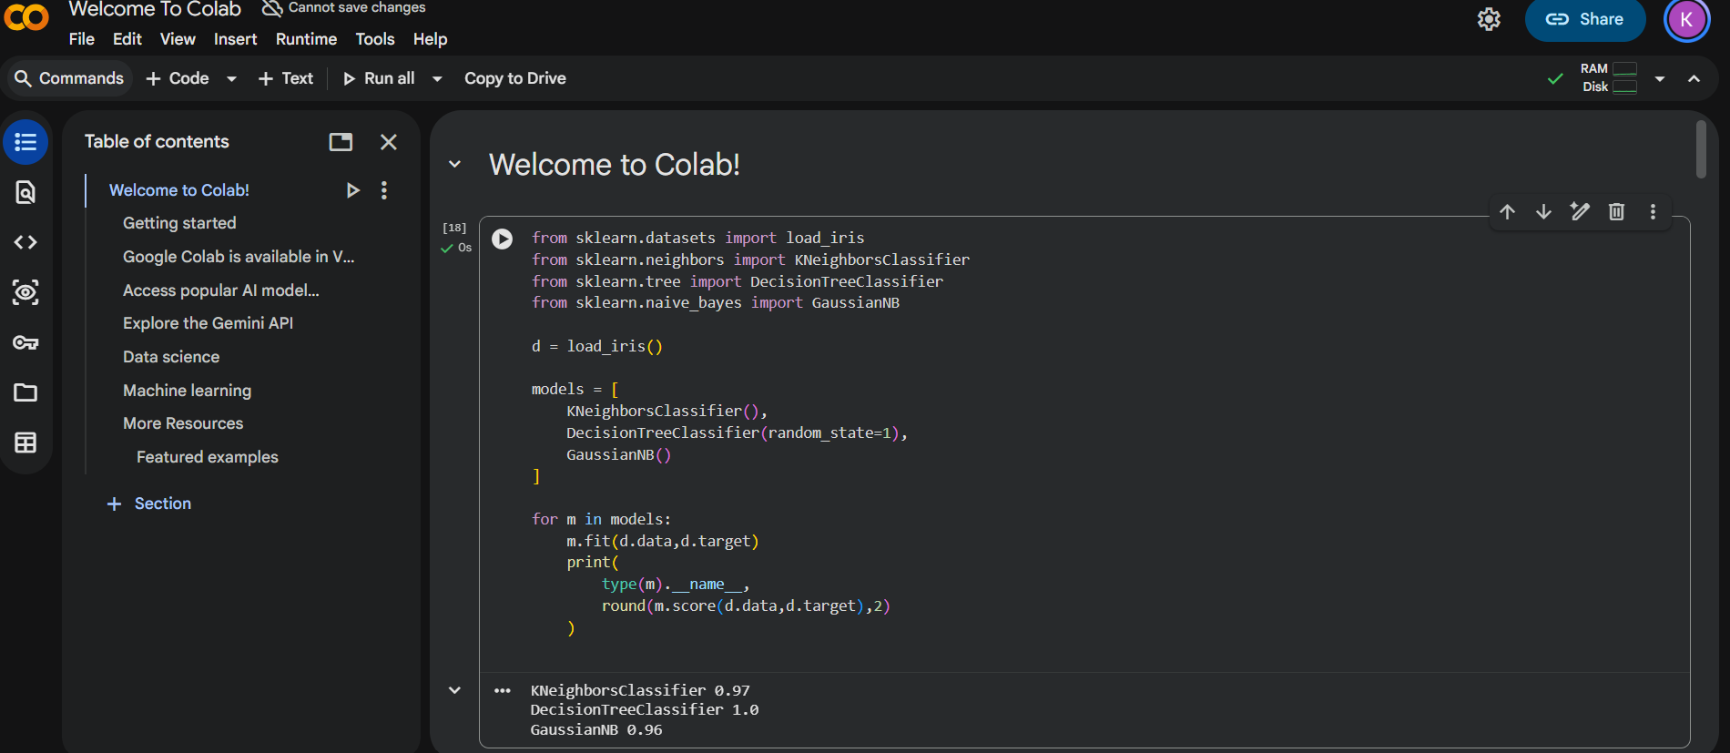

# 17. MOBILE PRICE PREDICTION
from sklearn.tree import DecisionTreeClassifier
X = [
[2,2000],
[4,3000],
[6,4000],
[8,5000]
]
y = [0,1,2,3]
m = DecisionTreeClassifier(random_state=1)
m.fit(X,y)
print(m.predict([[6,4000]]))

Output
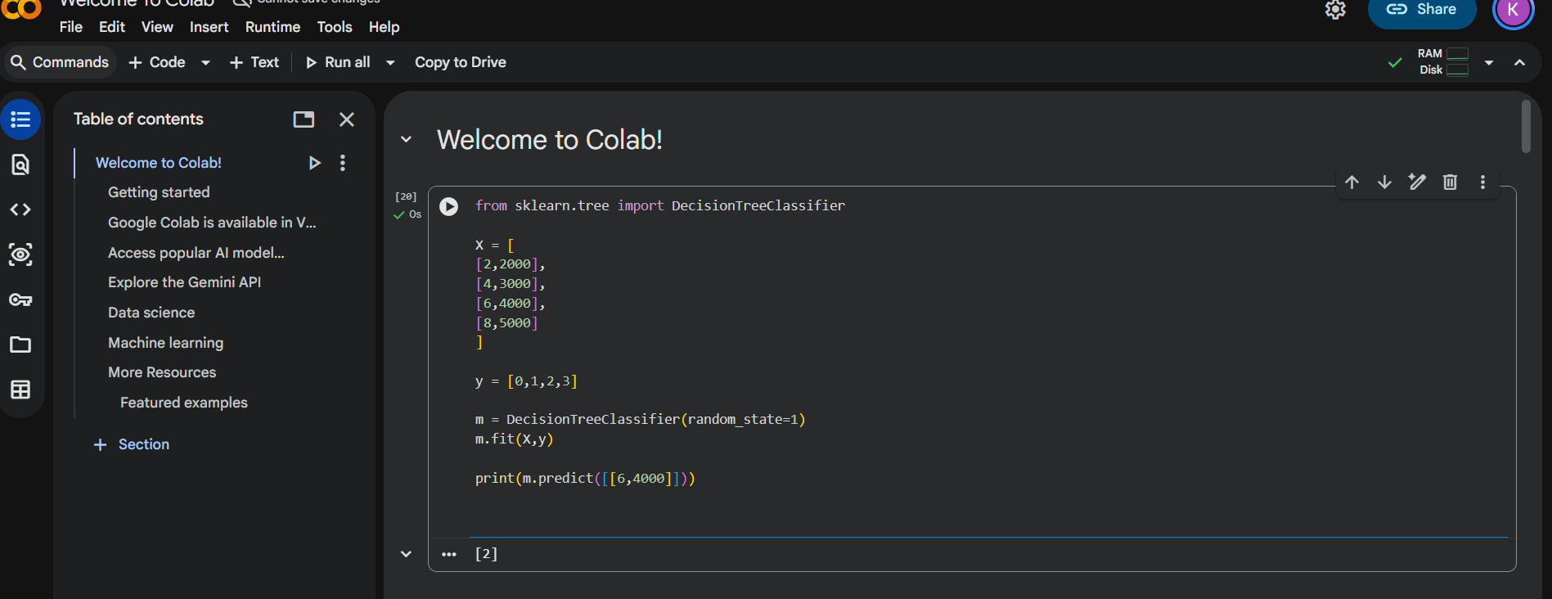

# 18. PERCEPTRON IRIS
from sklearn.datasets import load_iris
from sklearn.linear_model import Perceptron
d = load_iris()
X = d.data[:100,:2]
y = d.target[:100]
m = Perceptron(
max_iter=1000,
random_state=1
)
m.fit(X,y)
print(m.predict([[5.1,3.5]]))
Output
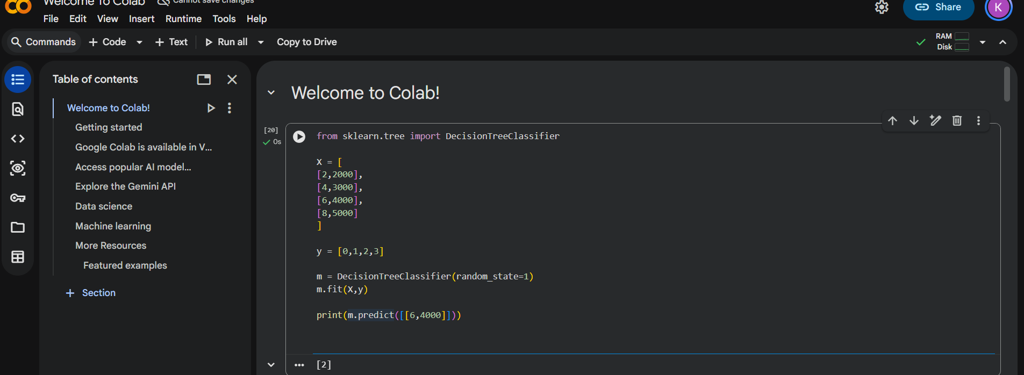
# 19. BANK LOAN NAIVE BAYES
from sklearn.naive_bayes import GaussianNB
X = [
[20,50000],
[25,40000],
[35,60000],
[45,90000]
]
y = [0,0,1,1]
m = GaussianNB()
m.fit(X,y)
print(m.predict([[35,60000]]))
Output
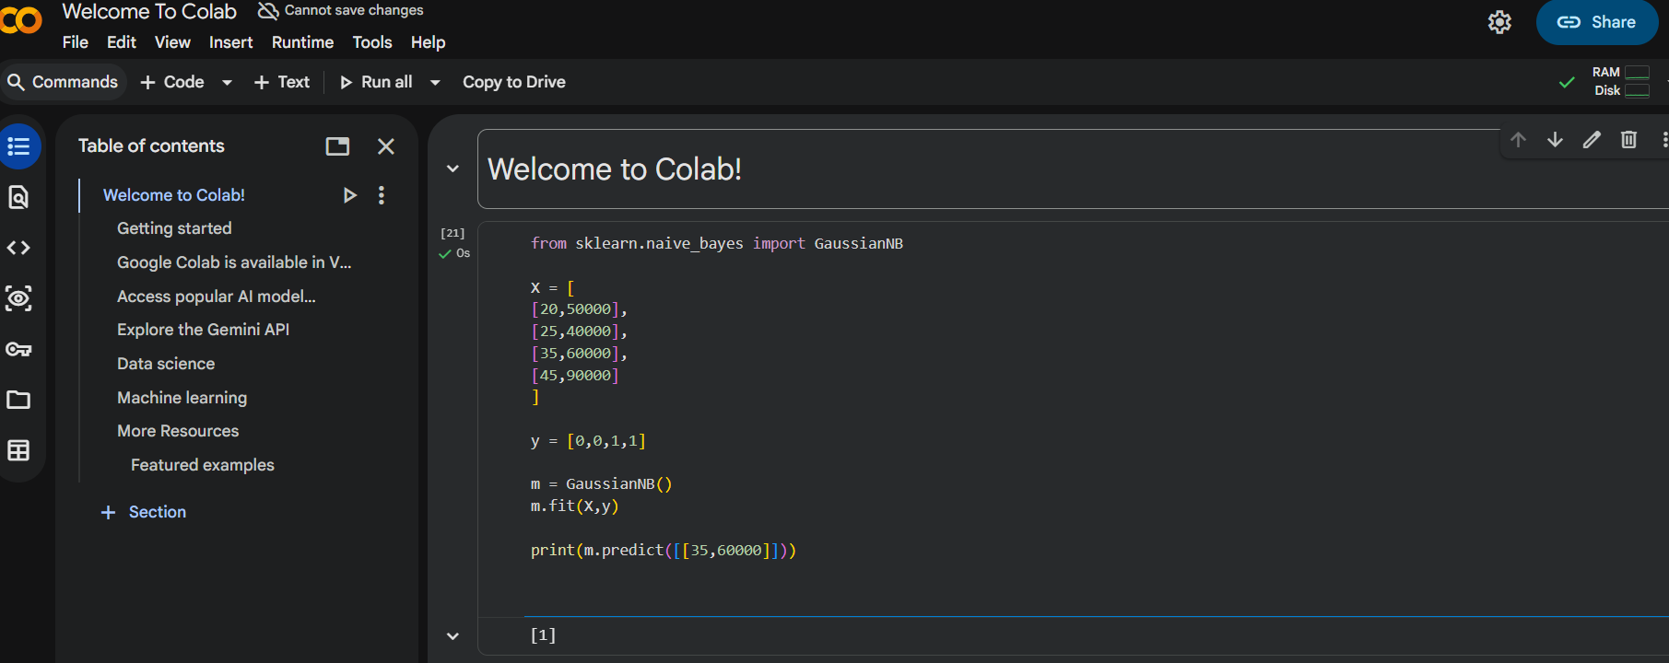

# 20. FUTURE SALES PREDICTION
from sklearn.linear_model import LinearRegression
X = [[1],[2],[3],[4],[5]]
y = [100,120,140,160,180]
m = LinearRegression()
m.fit(X,y)
print(
"Future Sales:",
round(m.predict([[6]])[0])
)
Output
